**BLACK POWDER IN GAS PIPELINES**

**Presented to the 2014 Texas Gas Association Conference San Marcos, TX, Nov. 13, 2014**

**John S. Smart John Smart Consulting Engineers, Houston TX email:** [**jacksmartiii@hotmail.com**](mailto:jacksmartiii@hotmail.com) **tel 281 493 5946 cell 832 656 5946**

1. **Black Powder in Pipelines**

Black powder is the name given to the black particulates and sediment found in pipelines. In this paper, the following topics will be discussed to give an understanding to this common problem.

1. what is black powder,
2. how it forms in pipelines,
3. when does it move,
4. what kinds of problems does it cause , and
5. What Can Companies do to Control or Prevent It?
6. **What is Black Powder**

**II.A Description**

Black Powder is the mixture of fine particle corrosion product and other solids found in pipelines. It occurs in both liquid and gas pipelines. Most of it is corrosion product but there are numerous other sources such as hydrotesting, plant upsets, off-spec gas in the line, frac sand and formation sand, clay and sand from hydrotesting, and salt from producing wells. In liquid lines, it can also come from producing wells. Some authors have declared black powder to be only iron sulfide. This is not the case, as some black powder is a mixture, in some cases it is all iron sulfide, while others have other iron compounds such as mill scale and iron carbonate but no iron sulfide. It is called “black “ powder because the presence of iron salts make it black, although it can also be rust colored (rouge) or even gray. The one thing it is not is the black powder used to shoot guns.

**II.B Sources of Black Powder in Pipelines**

Most black powder is generated by corrosion in the pipeline caused mainly by having “wet” gas, that is, gas with enough water to support corrosion (Ref, 1,2,3,4). Corrosion does not occur when there is no liquid water in the pipeline, although gas with a relative humidity of more than 69% can cause some small amount of corrosion if there are salts or acid gases in the pipeline which absorb water. (Ref. 5). The usual types of salts in produced water do not have this characteristic, for instance equilibrium humidity of sodium chloride is 90%, and pipelines are cleaned of most hygroscopic salts like CaCl2 and ZnCl2 salts when they are hydrotested.



**Figure 1**

**SEM Photomicrographs of Black Powder. Particles range from about 100 microns and smaller. SEM Photomicrographs courtesy of Edgar Zapata, Anderson & Associates, Inc., Houston, Texas 77034**

The corrodents in natural gas pipelines include carbon dioxide, hydrogen sulfide, oxygen, organic acids such as acetic acid, and bacteria. In pipelines, however, gas is nominally dry, typically with a water content of 7 pounds/MMSCF or less in the US, and there must be liquid water to have corrosion. Seven (7) Pound gas has a dew point of 12oF in 600 psi gas, 32oF in 1000 psi, and 43oF in 1500 psi gas. Here pound gas is usually specified in Europe, where temperatures can be lower. Three pound gas has a dew point of 10oF in 1000 psi gas.

In gathering lines, cooling of gas will cause water to condense in a gas line where it can not only generate black powder but also cause top-of-the-line corrosion if the water condensation rate is too high. Top-of-the-Line corrosion is not normally a problem on land based pipelines, occurring mainly in offshore lines where hot wet gas is cooled by seawater outside the pipeline.

The quantities of these compounds and water in pipeline quality gas is shown below, in Figures 2 a,b,c,d based on data collected by the Southwest Research Institute (Ref. 1) .

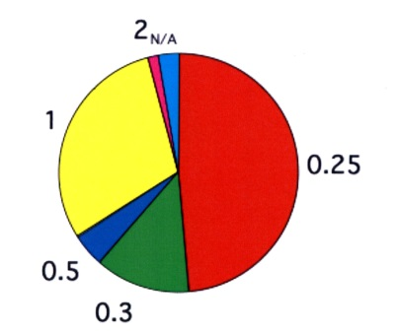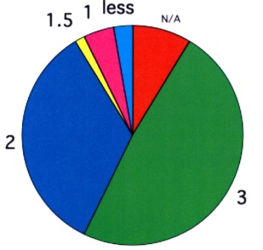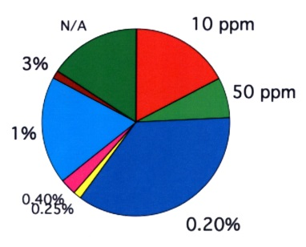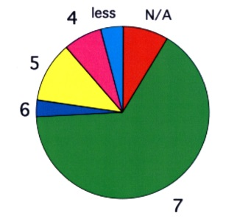

(a) H2S Allowed (b) CO2 Allowed (c) Oxygen Allowed (d) Water Allowed

Grains/100 CF Volume % Vol% or ppm pounds/MMSF

**Figure 2 Contaminants in Pipeline Natural Gas (Ref. 1)**

Correlations for the corrosion rates from these compounds are available individually, with some rules to determine which species is controlling when both H2S and CO2 are present. The one normally overlooked is oxygen. Oxygen acts as a cathodic depolarizer, that is, it breaks down the polarization film that is normally the rate controlling step in corrosion, thereby increasing the rate. The effect can be quite dramatic, as can be seen in Figure 3 (Ref. 5). However, the main determinant of corrosion in natural gas lines is the amount of liquid water present.

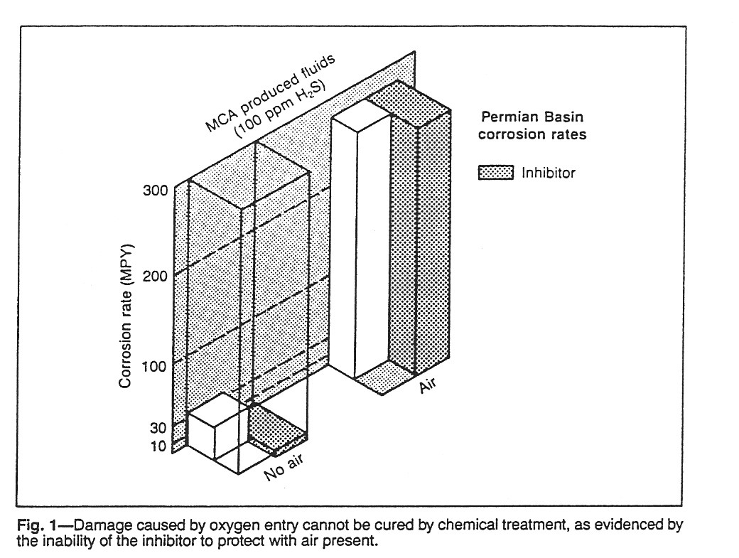

**Figure 3**

Effect of oxygen on the corrosion rate of sour natural gas with and without corrosion inhibitor (Evans).

**Other Compounds**

Other components found in black powder include iron oxides (mill scale and rouge), sand, salts, clays, gas plant dessicants such as silica gel, weld flux, weld rods, and other construction debris. Sometimes when gas plants are brought onstream after a turnaround, debris left over in the plant can be swept into the pipeline. This strategy will seem at the moment to be without consequences as long as the pipeline is operating below the velocity at which solids are moved by velocity, called the entrainment velocity. This will be covered in the next section.

In a similar mode, Figure 4 shows a section of gas pipeline into which a producer had offloaded a new well resulting in these salt deposits inside the line. While not visible in this picture, there had to be a huge amount of water injected into the line at the same time which undoubtedly generated a lot more black powder downstream. Also, the operator had to pig or flush this material out of the line afterwards.

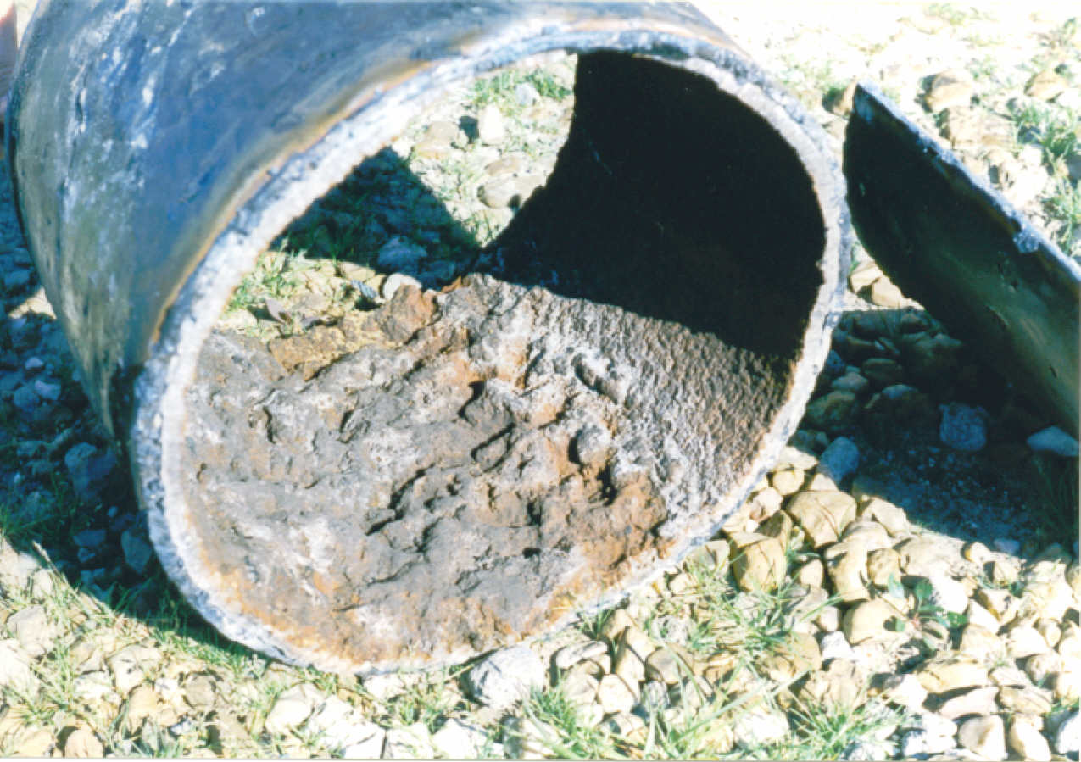

**Figure 4**

Gas pipeline into which a well had been unloaded resulting in salt deposits and a potentially large amount of water in the line.

**TEG in Black Powder**

Transmission line gas dehydrated with TEG carries a small quantity of glycol into the pipeline in two forms, mist carry-over and a further small quantity as vapor (Ref. 7). This leads to condensation of TEG-water homogenous solutions that are high in TEG content, typically in the range of 97-98 wt% TEG (Ref. 7, 8). For example, HYSYS simulation using the operating conditions of a gas treating plant with 7 lb/mmscf water specification, showed that the composition of the condensed TEG-water solution is 97.66 wt% TEG and 2.34 wt% water (Ref 9). Because TEG is heavy, viscous and has very low vapor pressure, it collects on the internal walls of the pipelines and becomes mixed with various residuals such as salts, corrosion products, sand and other contaminants. This mixture forms a layer of black sludge under which corrosion could occur only very slowly, less than 1% of the deWaard and Milliams spreadsheet rate (Ref.10 ).

Normally, glycol is a low corrosive media with a pH above 7. However, glycols can become corrosive due to either thermal breakdown or bacterial alteration. Several strains of bacteria are capable of using ethylene glycol and propylene glycol as sole sources of carbon. (Ref. 11) Concentrations above 10% have toxic effects on yeasts and fungi from soil, but not necessarily on glycol utilizing bacteria. Since the equilibrium concentration of TEG with 7# gas is 97+% or higher, then bacterial degradation of TEG is not expected in the pipeline.

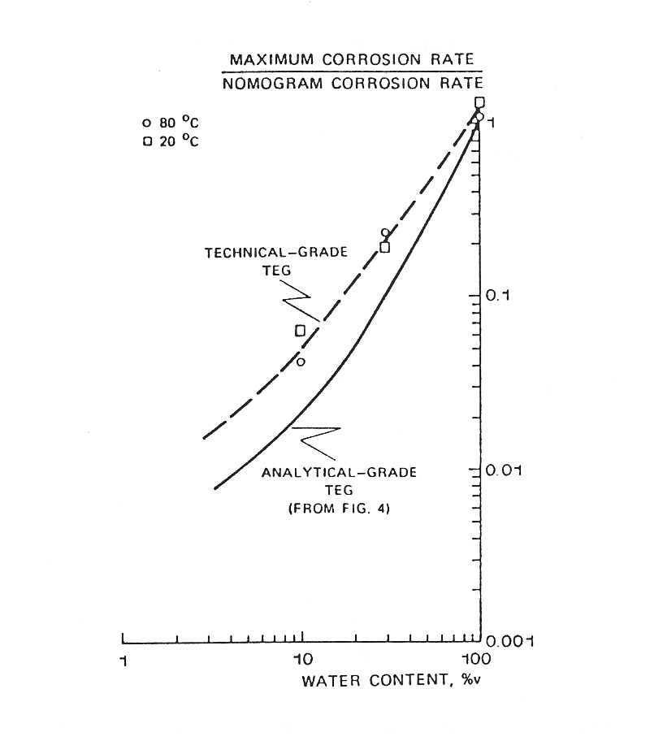

**Figure 5**

**Effect of Glycol on CO2 Corrosion of Carbon Steel (Ref.10)**

Another source of black powder is from movement from an upstream point with gas flow. Frequently, black powder lies in a consolidated from in the bottom of a line, glued together with heavy hydrocarbons, glycol or corrosion inhibitors. If the line is pigged, the powder becomes free to move and can travel long distances until removed by a filter separator at a compressor station. Normal filters do not remove this material very well and it can damage equipment downstream.

1. **Movement of Black Powder in Pipelines**

**III.A. Entrainment Velocity for Black Powder in Pipelines**

Black powder and any other particulate solid can be swept through a pipeline by fluid velocity. A technique to calculate the velocity required to sweep solids through horizontal pipelines by fluid drag has been developed by Wicks ( Ref. 12). A similar analysis has also presented by Wicks and Fraser (Ref. 13) to predict the entrainment velocity for water in flowing oil, one of the most important and fundamental methods for analysis of internal pipeline corrosion. The following analysis was developed to predict at what fluid velocity particulates can be dislodged from a bed of loose particles in the bottom of a pipe, and then carried through the pipeline. Higher velocities are required when the particles are wet by compressor oil or glycol or are “glued” together by paraffins, asphaltenes, or corrosion inhibitors. The following section reviews the development of Wicks’ analysis. (Ref. 14, 15)

**III.B Solids Deposits in Pipe**

If a single particle exists in a pipeline, it is affected by several significant forces, including:

* Gravity,
* Buoyancy,
* Lift, and
* Drag

A schematic of the forces acting on a particle in a bed of particles is shown below in Figure 6. Gravity and buoyancy are constant, while lift and drag vary with flow conditions, depending on inertial and viscous forces in the fluid. At low flow rates, gravity and buoyancy predominate, and particles settle to the bottom and form a layer of sediment. The sediment layer continues to build until the velocity in the remaining cross-sectional area is high enough to move the particles along.

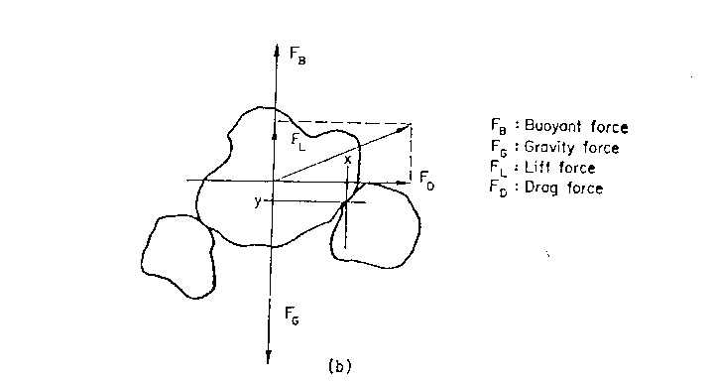

**Figure 6**

**Forces acting on a typical particle at the top of a bed of particles, from Wicks (12)**

Once a particle is contained in a bed, it must be “rolled” out of the bed before any net motion can occur. To start a particle moving, the forces acting on the particles must be such that the sum of the buoyant, lift and drag forces must be greater than the gravity force. A shape factor must be introduced for a non-spherical particle in order to estimate the rolling force required to move irregularly shaped particles. The shape factor is given as the ratio of the volume to the area of the particle, and results in an “equivalent diameter” for the particle, larger than the actual diameter.

At intermediate velocities, viscous forces become important and partic les begin to move if they can be lifted out of the sediment layer or scraped off the wall by pigging. The nature of particle motion depends strongly on gravity, but also on particle shape and the roughness of the surface over which the particles move.

* Rounded particles roll, especially if the surface is smooth;
* Long Thin particles slide if the surface is smooth or may tumble if it is rough;
* Rough or irregularly shaped particles move in a succession of bounces called “saltation flow”;
* Flake-like particles can move like leaves in the wind if they can be lifted by viscous forces or pushed by pigging.

At high enough velocity, the particles follow the fluid with some segregation at the bottom due to gravity until a homogeneous flow condition is reached when the gravitational forces are insignificant compared to the viscous forces.

When solids accumulate in beds in a pipeline, they are sometimes “glued” together by paraffins, tars, corrosion inhibitors or other substances to form a crust, or they can be wet with compressor oil or glycol in gas pipelines. Neither of these effects are accounted in Wicks’ analysis. When a pipeline is pigged, however, the pig dislodges the particles from the wall and fluid velocity only needs to sustain particle motion rather than to be able to dislodge the particles from a bed.

By analysis of the various forces acting on a particle, Wicks derived two expressions containing the hydrodynamic parameters affecting a particle:

**Ψ** = ρf**3**d V4 **Eqn. 1** (ρp - ρf ) gLμ2

and

**S = DeqVs** ρf (d/Dp)2/3 **Eqn. 2** μ

By comparison to experimental data, shown in Figure 2, a correlation was developed, given in Equation 3, where the two parameters are related by:

**Ψ** = **S3 /(10+0.01S3/2) Eqn. 3**

The correlation cannot be solved analytically, but can be solved by trial and error, and provides the basis for the solids entrainment analysis.

In the following sections, this correlation has been used to predict what velocity is required under conditions for:

1. sand in water and oil,
2. iron compounds such as iron oxides, iron sulfide, and iron carbonate in water and various oils,
3. black powder in gas.

Several assumptions and factors must then be applied to the results:

1. Calculation results are for dilute concentrations of solids where the viscous forces from one particle do not affect others;
2. The particle diameter used in the analysis is the effective particle diameter, given by a shape factor times the characteristic diameter such as the average sieve size. Shape factors are in the range of 1.5-2 for most pipeline solids, and is the particle perimeter divided by pi;
3. Results are for horizontal pipelines, with an additional factor of 10-15% required to be able to push particles uphill in real pipelines, possibly more for very steep hills.
4. In more viscous oils, there will be some time before a solid particle will settle to the bottom if it is pushed toward the center of the pipeline by the pig.
5. Vertical pipe sections such as risers should use Stokes Law to determine the velocity required.

**III.C Results for Entrainment Velocity for Various Solids in Liquids and Gas**

**Case I Velocity to Move Sand in Pure Water**

**Figure 7**

**Water Velocity to Move Sand in a Pipeline, sand diameter in microns**

Figures 7 show the calculated velocity to move sand in pure water at 60oF vs. sand particle effective diameter and pipe size. Sand effective diameter is given in microns. The velocity required depends upon pipe diameter but is fairly constant for sand particles greater than about 20 microns. For 8 inch pipe, the required velocity is about 2.5 ft/sec for 100 micron particles up to 3.2 ft/sec for sand in a 24 inch pipeline. Pipe diameters indicated on these charts is nominal pipe size, with the internal diameter reduced to Sch. 40 pipe. This velocity must be increased to about 3.5 – 4 feet per second to be able to push sand uphill. In three phase produced fluid lines, the water velocity at the bottom of the line is the important parameter. This can be estimated based on research work on multi-phase flow and from superficial water velocity and liquid hold-up in the line.

**Case 2 Velocity to Move Sand in Brine**

**Figure 8. Velocity to Move Sand in 5% Brine at 100oF.**

In oil and gas production, the produced water is usually not pure but a brine in the range of 5 – 10% or more salt. Figure 8 shows the velocity to move sand in 5% brine at 100oF for pipe from 4 inch to 24 inch nominal diameter horizontal pipe. Comparison to the same calculation for 10% brine indicates that the velocities for all concentrations over this range are virtually identical, indicating that the brine density and brine viscosity effects virtually cancel each other for these conditions.

**III.D Iron Compounds in Oil**

**Case 4 Iron Sulfide in Oil**

**Figure 9 Fluid Velocity to Move Iron Sulfide in 40oAPI Oil**

Iron compound corrosion products are also produced in oil and gas wells, and travel through process equipment and frequently into pipelines. Iron sulfide, in particular, is an oil wet mineral and is associated with the oil layer in produced fluids. Figure 9 shows the oil velocity at which iron sulfide begins to move in 40oAPI oil as a function of particle diameter and pipe size. The solids movement velocity in this case is much higher than for sand in water, from 5.5 ft/sec in 8” pipe to over 8 ft/sec in 48 inch pipe. Figure 9 can be used to approximate any iron compound or group of compounds as the specific gravities of 3.8 for Iron Carbonate, 4.82 for FeS, 5.1 for Fe3O4 and 5.24 for Fe2O3 and the fluid velocities to move other compounds are similar. Due to its lower density, iron carbonate would move at a slightly lower velocity than shown, and a comparison of the movement velocity of the various minerals reported for black powder in gas pipelines is given in Figure 16.

These velocities may not always be possible and pipelines that have lower velocities will accumulate solids in the bottom of the line. These solids can accumulate to a height shown in Figure 10 for a 24 inch line. This is more likely to happen in the later life of a pipeline, but most lines are designed to have velocities in the range of 5 – 8 ft/sec, intended to keep them free of both water and solids. Thus a 24” pipeline operating at at less than 6.5 ft/sec would act as a long thin separator. A picture of such a line is shown in Figure 13.

**Case 5. Iron Compounds in 20oAPI Oil**

**Figure 10 Fluid Velocity to move iron compounds in 20oAPI oil**

The fluid velocity required to move iron sulfide in 20oAPI Oil is shown in Figure 10. This is a higher velocity than in 40o API Oil as the laminar boundary layer on top of a bed of particles is thicker due to the higher viscosity. This higher fluid velocity requirement means that any pigging operation in heavier crude oils may be more difficult and will require better planning, necessitating pigging procedures such as Progressive pigging, use of jetting nozzles at the front of the pig and possibly requiring gel pigging if the line must be cleaned in a single pass.

**Iron Compounds in No. 2 Diesel**

Diesel is sometimes used for cleaning pipelines as the compound is relatively inexpensive and available, and much of it can be recovered or sold. The fluid velocity for entrainment of the same iron compounds is shown in Figure 11. Eight inch lines require a fluid velocity of over 6 ft/sec to move iron sulfide particulate solids, while a velocity of nearly 10 ft/sec is required for a 48 inch line.

**Figure 11. Entrainment Velocity for FeS in No. 2 Diesel at 60oF**

When pipelines are cleaned by pigging, No. 2 Diesel is often used as it is readily available, is easily separated from the sediment and can be recovered and recycled. Figure 11 shows the movement velocity for FeS in No. 2 Diesel as a function of pipe diameter and FeS particle size. As can be seen, the entrainment velocity is lower than either 20oAPI crude oil but slightly higher than 40oAPI crude oil, requiring nearly just over 8 ft/sec for 24 inch lines. If the lines are operated below this velocity while pigging, iron sulfide particles will drop out ahead of the pig and could develop into large plugs that can stick the pig. This means that diesel is not a particularly good fluid to use when cleaning very dirty pipelines by pigging. Also, with a 10% safety margin added in for up-hill flow, these numbers may be a bit optimistic. Therefore, by-pass pigs with jetting nozzles, progressive pigging, or gel pigging are better design pigging programs for lines with significant amounts of iron oxides, sulfides and carbonates in them.

**Bed Height vs. Fluid Velocity**

When the fluid velocity is less than the particle movement velocity, then beds of sediment will build up in the pipeline, reaching some steady state value if enough sediment is in the line. Figure 12 shows the steady state bed height for 1 micron iron sulfide particles in 24 inch pipeline containing No. 2 diesel, with a sp. gr. of 0.86 inch and viscosity of 9 Cp.

**Figure 12**

**Steady State Sediment bed height for FeS in a 24 inch pipeline carrying No. 2 diesel at 60oF.**

When a pipeline is operated below the solids movement velocity, the pipeline will act as a separator and solids will settle to the bottom until they reach the height shown in Figure 12. This volume will only be reached, however, if there are enough solids in the line and they are allowed to accumulate. Lines are pigged for cleaning for ILI inspections or operating efficiency reasons. In one long serving former sour crude line that had never been pigged, over 6000 pounds FeS solids per mile were removed by pigging.

Another example of sediment is a crude oil pipeline shown in Figure 13, from a section of a 20 inch crude oil pipeline. The accumulation of solids in a pipeline can be enormous, and can cause pigs to become stuck if the pigging procedure is not designed to clean the line gradually such as in progressive pigging, or by use of gel pigs to suspend the sediment ahead of the pigs. Estimating the depth of solids contained in the pipe shown in Figure 13 as 0.5 inches deep in a 20 inch diameter pipeline, the volume of solids is about 22 ft3/mile and weighing about 2 tons as iron oxides. If the sediment were 1 inch thick, the weight of iron oxides would be about 9 tons per mile.

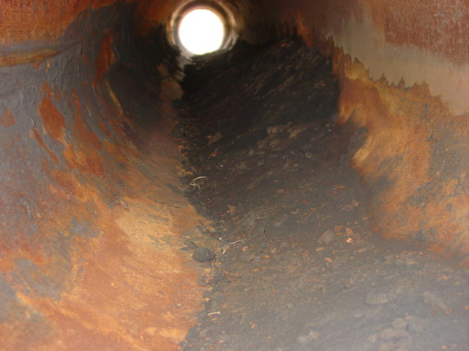

**Figure 13**

**Iron sulfide (originally) sediment in a 20 inch pipeline. The volume of sediment can be enormous and must be considered in pig cleaning operations for disposal as hazardous waste.**

Build-up of solids in front of a cleaning pig also can cause a pig to “stick” by accumulating solids in front of a pig with a velocity too low to move them by velocity alone. The solids would then fall out ahead of the pig and accumulate, and eventually the pressure drop across the pig can no longer move the accumulated sediment. An example of fine iron oxides in a products pipeline carrying motor gasoline, propane/butane and diesel is shown in Figure 14. The line was operated in intermittent service. When pigged with a criss-cross poly-pig, the pig became stuck and over 200 feet of the line had to cut out and replaced.

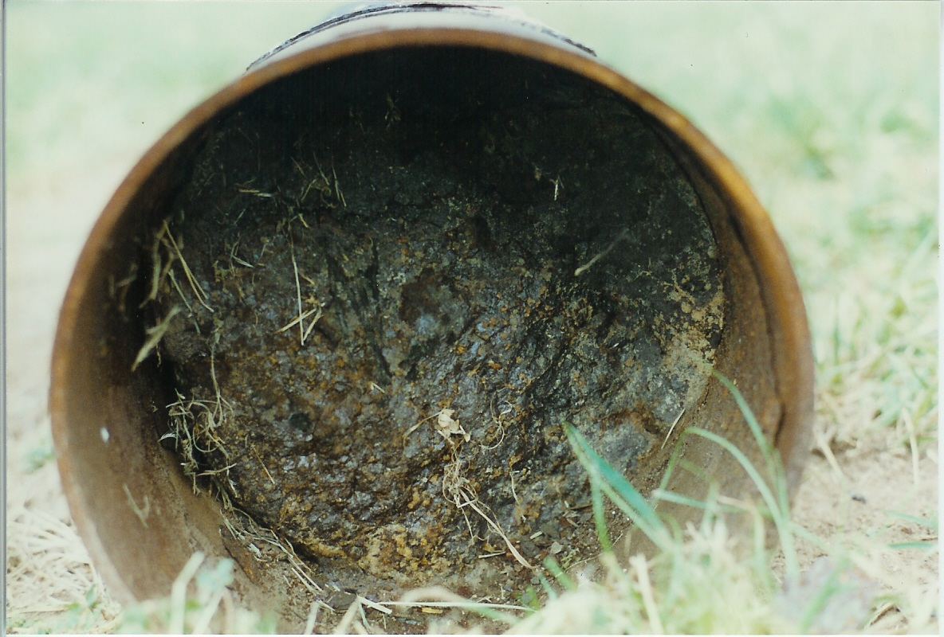

**Figure 14**

**Products pipeline plugged with sediment during pigging. 200 feet of line had to be cut out and replaced.**

1. **Black Powder in Natural Gas Pipelines**

**IV.A Black Powder has Become a common operating Problem**

Black powder has become a major operating problem in natural gas pipelines, threatening the reputation of natural gas as a “clean” fuel.

Figure 15 shows the velocity to move black powder in natural gas pipelines operating at 1000 psi and 60oF. Gas velocity required to move black powder under these conditions is 13.5 ft/sec in 48 inch pipe, down to 9.5 ft/sec in 8 inch pipe. Natural gas pipelines can vary in their flow velocity depending on the season, and may cycle above and below this number. If the pipeline were operated even in a slightly corrosive condition, even just enough to cause mill scale to flake off the inside wall, large amounts of black powder could result that could possibly be delivered to customers, or, at the least, require substantial filtering before delivery.

**Figure 15**

**Gas Velocity to Move Iron Sulfide solids in a Natural Gas Pipeline as a function of pipe size at 1000 psi and 60oF.**

The relative velocity to move other black powder minerals is given in Figure 16, under the same conditions of 1000 psi pressure and 60oF in a 24 inch natural gas pipeline.

**Figure 16 Velocity to move various Black Powder Minerals in a 24 Inch Natural gas Pipeline at 1000 psi and 60oF**

Figure 17 shows the effect of pipeline operating pressure on the velocity required to move 1 micron diameter and finer black powder particles in 8 inch through 48 inch pipelines. The important result of

**Figure 17 Flow Rate of Natural Gas to move 1 Micron Black Powder vs. gas pressure and pipeline diameter.**

this calculation, besides the velocity required, is that once black powder starts to move in a gas pipeline, it will continues to move until either it arrives at a compressor station that removes it with filter separators, or the flow rate is reduced.

These results explain why gas pipeline compressor stations need to have filter-separators installed in front of all compressors, to catch black powder coming down the pipeline. Pipeline operators report that as black powder is transported down a pipeline, it fractures and becomes very fine, with a size in the range of 1 micron. Extremely fine powder like this can pass through normal pipeline filters, requiring very fine sub-micron filters be used. They also report that extremely fine powder such as 1 micron can be tolerated by reciprocating compressors, but can damage turbine compressors, even with filters in place. Figure 18 shows a standard gas pipeline filter with cartridge elements in place upstream of a large gas fired diesel engine used to generate electrical power. This filter did not prevent fine iron oxide from penetrating into the engine and shutting it down by shorting out instrument controls.

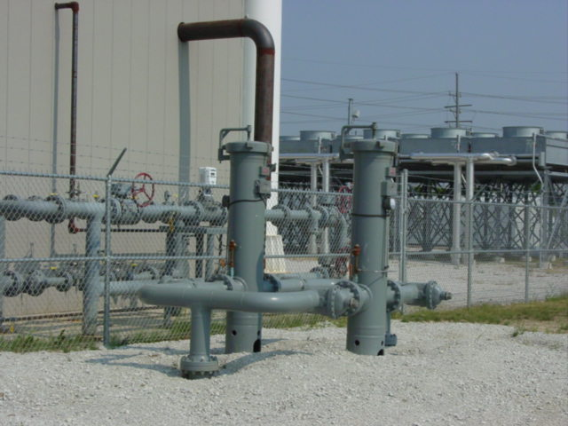

**Figure 18**

**Dual cartridge filters, each with 7 cartridges, which failed to remove iron oxide from gas used to operate a gas fired diesel engine for power generation.**

Conversations with pipeline operators reveal that when pipelines are cleaned for such purposes as ILI inspections, the use of chemical cleaning can initially result in a clean line. Chemicals used are either surfactants designed to water wet the particles and removed them with water or a chemical compound that dissolves black powder by chelation without damaging the pipeline. This chemical can also remove black powder from areas that the pig cannot reach. However, after some time, black powder is usually found coming down the line again even when the lines are dry and solids are not being generated by internal corrosion. Thus much of the black powder problem in gas pipelines is likely due to migration of solids rather than generation of new powder in the line.

Many gas pipelines are not dry, however, but contain compressor lubricating oil and other liquids such as glycol which can “glue” solids to the wall of the pipe and keep them from moving. One other technique to keep black powder from moving is to treat the line with a corrosion inhibitor. Inhibitors are tacky compounds and will “glue” powder in place, but must be treated periodically. Figure 19 shows reported field results for cleaning of wet black powder from under a series of river crossings compared to dry powder. In this case, solids were measured as they arrived on the downstream side of the river with carefully measured pressure drops and flow rates.

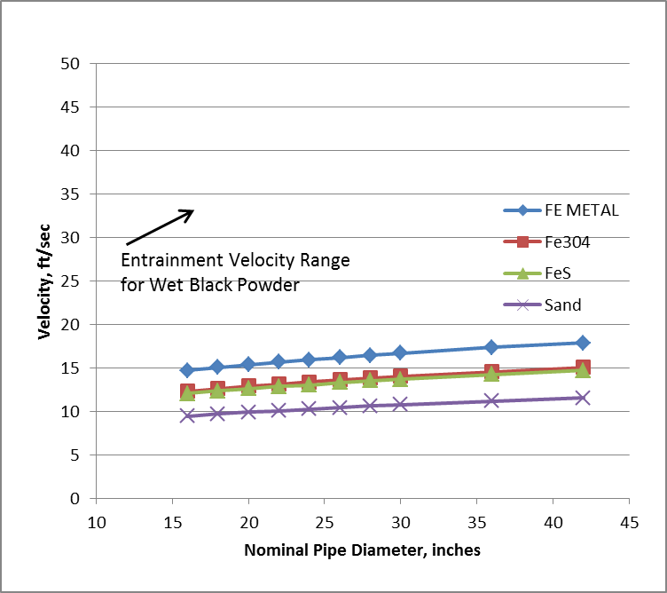

**Figure 19**

**Sweep velocity for wet black powder in gas pipelines under a series of river crossings**

**Problems Caused by Black Powder**

The following section discusses some problems caused by black powder:

* 1. **Pyrophoric nature of Iron Sulfide**

Iron sulfide is pyrophoric, that is, it will ignite when exposed to air. Figure 20 shows a filter separator on a sour gas pipeline which was opened for cleaning. The vessel was first filled with carbon dioxide to minimize the chances of fire, and once open, the vessel was continuously doused with water to prevent ignition.

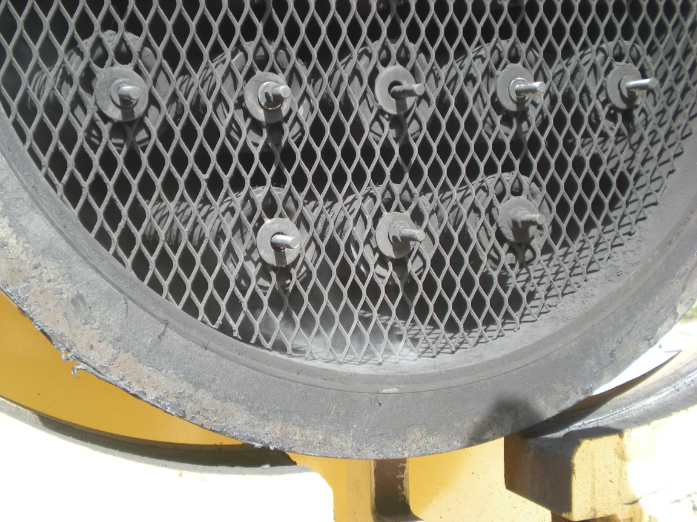

**Figure 20 Filter separator on a sour gas pipeline with iron sulfide black powder just after opening the door. Note the white smoke at the bottom from iron sulfide oxidizing to SO2 and iron oxide just before catching fire.**

Figure 21 shows some sour gas filter elements after removal from the filter separator, which ignited shortly after removal. Materials contaminated with FeS black powder must be wet down with water immediately upon exposure to air.



**Figure 21 Iron sulfide black powder filter elements after being removed from a filter separator (Ref. 1)**

* 1. **Abrasiveness of Black Powder – Centrifugal Compressor Impeller**

Black powder is very abrasive to compressor equipment and gas generators. Figure 21 shows an impeller disc from a centrifugal compressor that lasted about one day when black powder entered with the gas. In this case, an increase in the flow rate in the pipeline due to increased demand caused the line velocity to exceed the entrainment velocity for black powder which inundated the plant, which could not change its filters fast enough and finally ran out of elements.

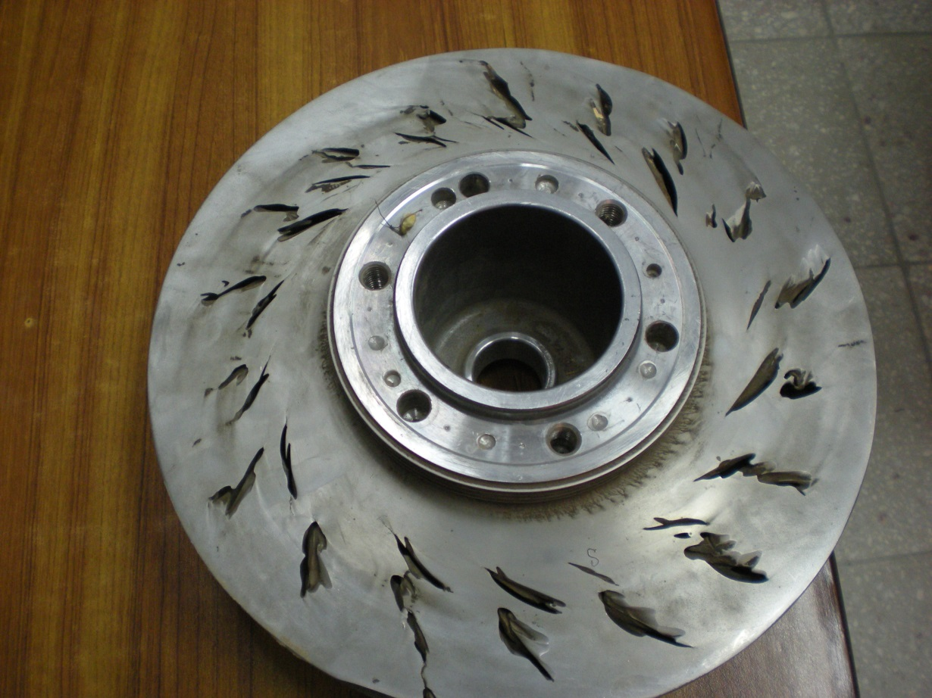

**Figure 21**

**Impeller from a centrifugal compressor eroded in one day by black powder**

**3. Black powder on Gas Turbine Blade**

Figure 22 shows a gas turbine blade which was eroded away when black powder began arriving at the plant. There were two turbines in a peak shaving electric generation plant served by a 16 inch pipeline. The plant used only one for about a year, and then had to use the second. When only one turbine was operating, the velocity in the line was approx. 0.8 times the entrainment velocity. When the second turbine was fired up, the ceramic coating on the gas cooled blades was fluxed by the iron salts and melted, while the black powder eroded the blade at the same time. The source of the black powder was traced to a section of the transmission line over 75 miles upstream that had been pigged several months previously. There were filters on the supply line to the turbines but they had not prevented the problem. This makes an interesting legal problem as the commercial code in many states requires that something sold must be suitable for the use intended.

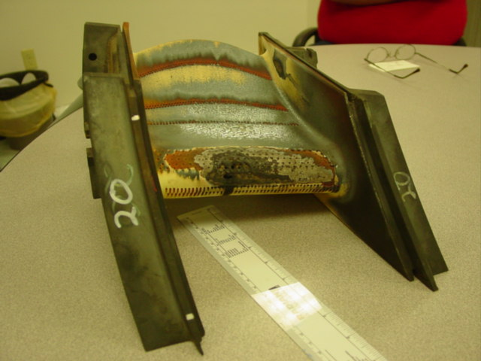



**Figure 22**

**Ceramic coated gas cooled Gas Turbine blades which were fluxed by black powder entering the turbine. This gas fired turbine as used to power an electric generator.**

1. **Flow Inefficiency in Pipelines**

A presentation on Pipeline Efficiency and Operating Costs vs. Cleanliness was made by a major operator at a panel discussion at the 2010 Pipeline Pigging and Integrity Management Conference, February 2010 Panel Discussion on Cleanliness in Pipelines, Feb, 17, 2010 in Houston TX. In the presentation, the results of a pigging program were presented on cleaning a gas pipeline containing black powder. Approximately 80 miles of pipeline were pigged to clean the line. Results were excellent as the entire cost of the program was recovered in about 1 month from increased delivery of gas and from reduced fuel consumption of the pipeline compressors.

Tsochatzidis NA and Maroullis (Ref. 17) also reported on the problems caused by massive amounts of black powder arriving at a terminal in Greece from eastern Europe. The terminal has to install a centrifugal separator to separate the black powder, which they hauled off by the truckload. Figure

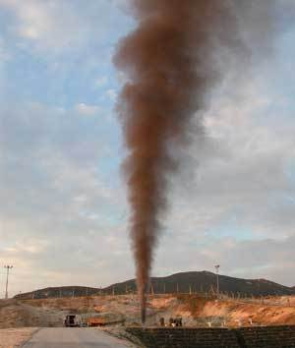

**Figure 23 Pig Receiver in terminal in Greece being blown down to remove black powder**

**VI Solving Black Powder Problems**

Solving black powder problems requires a two prong approach: physical solutions, and management solutions. The two must work together.

**VI.A Physical stuff**

Baldwin recommended a number of steps that could be taken, like removing the corrodents from the system. Short of using LNG type technology such as molecular sieves to remove carbon dioxide and water, this is not very achievable. Control of water is probably the most achievable but upsets and being given off-spec gas can ruin this approach. It would help, however, to respond quickly when off-spec gas is detected. Several years ago, I analyzed a case on black powder generation during a period of gas shortage and pipelines were taking anything to make their sales commitments. Certainly this is an operational necessity at times, but management must be willing to commit to repairing the damage afterwards, such as chemical pigging the line to clean it and not penalizing pipeline operators for having to change filter separator elements.

A second very useful tool is to pro-actively determine the condition of your system. One very effective method is to run pressure drop vs. flow rate calculations on pipeline segments. Analysis with available computer programs can determine several parameters such as:

1. Effective internal diameter for comparison to the original, which can be used to estimate the volume of black powder in the line and help plan pigging programs;
2. Friction factors or roughness, which can be used to determine how much additional pressure drop and fuel consumption is required over a clean line.
3. Determine the entrainment velocity for black powder and do not exceed it.

Knowing the benefits of a pigging program for comparison to the costs can make for a strong proposal to management for the need to do this work. For this, I have long recommended that the operators and engineers of a company need to talk to each other on a regular basis. They and the company can both gain huge benefits from this type of joint effort.

Finally, gas transmission lines normally are not treated with corrosion inhibitors, but if one experiences black powder formation, corrosion inhibitors can be very helpful in reducing black powder formation. Injection should be commenced whenever the dew point of the gas is too high and would cause water condensation inside the line. This could be from plant upsets or off-spec supply, but these events do happen. A combination volatile amine plus filming amine is recommended for this application as the volatile amine will protect the upper walls of the pipe against condensation corrosion while the filming amine will protect the bottom. When properly dehydrated gas is resumed, it should remove any condensed water. In theory, TEG injection could be used but may not be practical unless it can be recycled effectively.

A second major benefit to using corrosion inhibitors is that they wet the solids with a sticky film. This allows operating to much higher velocities, and is recommended any time the entrainment velocity is approached in a pipeline. They are cheap insurance, but need to be used about every three months.

**VI.B. Management Participation**

A corporate culture for black powder control must exist in the company as no single group within the company can do it by themselves. For example, operators may not know there is a problem, but engineers can detect it with methods such as flow analysis even before equipment starts to fail or operating efficiency is compromised. Managers, operators, engineers, maintenance must work together to solve these problems. Managers need to recognize the need to enable their operating groups to communicate with each other to detect these problems and must budget for maintenance to keep problems from becoming really expensive such as shut-downs due to equipment failure.

For their part, operators and engineers must talk the language of managers, i.e. economics and return on investment, to justify and plan for maintenance procedures when they detect problems. After all, the goal of business is to make money, so engineers and operators must be able to express how solving of black powder problems translates into profits .

**REFERENCES:**

1. Richard Baldwin, “Technical Assessment: “Black Powder” in the Gas Industry – Sources, Characteristics, and Treatment,” Gas Machinery Research Council Report TA 97-4 May, 1998. Report available at www.gmrc.org/technology-reports.html Report 97-4
2. Sherik AM, Corrosion of Sales Gas Pipelines, EUROCORR Conference, Istanbul, Turkey, and September (2012).
3. Sherik AM, Black Powder: Study Examines Sources, makeup in dry gas system, Oil &Gas Journal, August 11 (2008a).
4. Sherik AM and Davis B, Thermodynamic Analysis of Formation of Black Powder in Sales Gas Pipelines, paper No. 09560, Corrosion NACE (2009).
5. H.H. Uhlig and W. Revie, Corrosion and Corrosion Control, An Introduction to Corrosion Science and Control, 3rd Edition, John Wiley and Sons, New York page 174
6. Sheldon Evans•
7. Smart J and Roberts R, “Possible Glycol Corrosion in Nominally Dry Gas Pipelines”, paper No. 06442, NACE Corrosion (2006).
8. Gartland O, Internal Corrosion in Dry Gas Pipelines During Upsets, PRCI Report No.8292, March (2003).
9. Sherik AM, Lewis AL, Rasheed AH, and Jabran AA, Effect of Triethylene Glycol on Corrosion of Carbon Steel in H2S, CO2, and O2 Environments, paper No. 10188, NACE Corrosion (2010).
10. L. van Bodegom, K. van Gelder, M.K.F. Paksa, and L van Raam “Effect of Glycol and Methanol on CO2 Corrosion of Carbon Steel” CORROSION87 Paper 55 NACE, Houston, TX
11. T Richard L. Ray, Brenda J. Little and Joanne Jones-Meehan “An Evaluation of Microbiologically Influenced Corrosion in Potential Fluids for Between-Hull Spaces” NACE CORROSION 2002 Paper 02435
12. Wicks“Transport of Solids at Low Concentration in Horizontal Pipelines” in Advances in Solid-Liquid Flow in Pipelines and its Applications, Edited by Iraj Zandi, Pergammon Press, New York, 1971 pg. 101-124).
13. Wicks, M and J. Fraser “Entrainment Velocity for Water in Flowing Oil Materials Performance, May, 1975
14. J. Smart , “Determining the Velocity Required to Keep Solids Moving in Pipelines” presented at The 19th Pipeline Pigging and Integrity Management Conference Houston, TX, February, 2007, Published in The Journal of Pipeline Engineering Vol. 6 No. 1 (1st Qtr, 2007) Flow Velocity Required for Solid Particle Movement in Oil and Gas Pipelines
15. J. Smart “Movement of Black Powder in Gas Pipelines” NACE Paper 10 Pipeline and Gas Journal, November 2010 pages
16. J. Smart “Black Powder Movement in Gas Pipelines” NACE CORR 11089, NACE International, Houston TX March 11, 2011
17. Tsochatzidis NA and Maroullis KE, Methods Help Remove Black Powder from Gas Pipelines, pp. 52-58, Oil & Gas Journal, March 12 (2007).